DBS & DB PRACTIAL WEEK – 2

CREATE DATABASE IF NOT EXISTS bookflow_db;
USE bookflow_db;
CREATE TABLE Books (
book_id INT PRIMARY KEY,
title VARCHAR(100) NOT NULL,
isbn VARCHAR(20) UNIQUE,
published_year INT CHECK (published_year < 2027)
);
INSERT INTO Books (book_id, title, isbn, published_year) VALUES
(1, 'The Great Gatsby', '9780743273565', 1925),
(2, 'To Kill a Mockingbird', '9780061120084', 1960),
(3, '1984', '9780451524935', 1949);
SELECT * FROM Books;
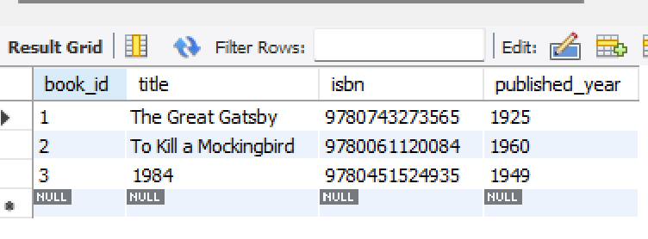
CREATE TABLE Members (
member_id INT PRIMARY KEY,
full_name VARCHAR(100),
email VARCHAR(100) UNIQUE
);
INSERT INTO Members (member_id, full_name, email) VALUES
(101, 'John Smith', 'john.smith@email.com'),
(102, 'Emma Wilson', 'emma.wilson@email.com'),
(103, 'Michael Brown', 'michael.brown@email.com');
SELECT * FROM Members;
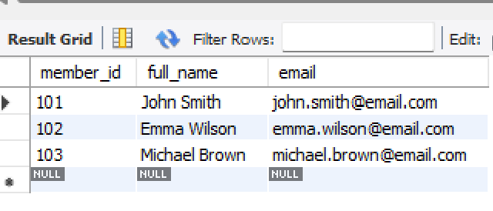
CREATE TABLE Loans (
loan_id INT PRIMARY KEY,
member_id INT,
book_id INT,
loan_date DATE,
FOREIGN KEY (member_id) REFERENCES Members(member_id),
FOREIGN KEY (book_id) REFERENCES Books(book_id)
);
INSERT INTO Loans (loan_id, member_id, book_id, loan_date) VALUES
(1, 101, 1, '2025-01-05'),
(2, 102, 2, '2025-01-08'),
(3, 103, 3, '2025-01-10'),
(4, 101, 2, '2025-02-01'),
(5, 102, 1, '2025-02-05'),
(6, 103, 2, '2025-02-12'),
(7, 101, 3, '2025-03-01'),
(8, 102, 3, '2025-03-07'),
(9, 103, 1, '2025-03-15'),
(10, 101, 1, '2025-04-01');
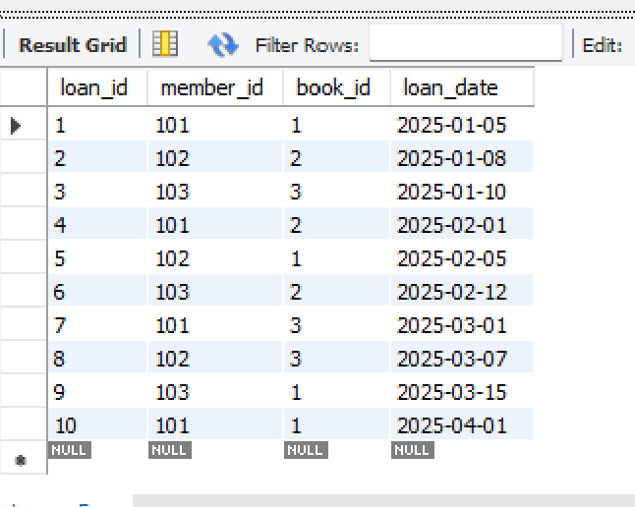
SELECT
m.full_name AS Member_Name,
b.title AS Book_Title
FROM Loans l
INNER JOIN Members m
ON l.member_id = m.member_id
INNER JOIN Books b
ON l.book_id = b.book_id;

SELECT published_year,
COUNT(book_id) AS Total_Books
FROM Books
GROUP BY published_year
ORDER BY published_year;
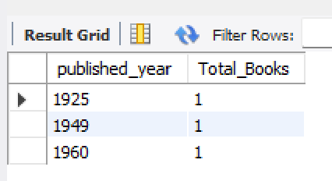
CREATE TABLE Donation_History (
donation_id INT PRIMARY KEY,
book_id INT,
donor_name VARCHAR(100),
donation_date DATE,
FOREIGN KEY (book_id) REFERENCES Books(book_id)
);
START TRANSACTION;
INSERT INTO Books (book_id, title, isbn, published_year) VALUES (4, 'Animal Farm', '9780451526342', 1945);
INSERT INTO Donation_History (donation_id, book_id, donor_name, donation_date) VALUES (1, 4, 'Raj Kumar', CURDATE());
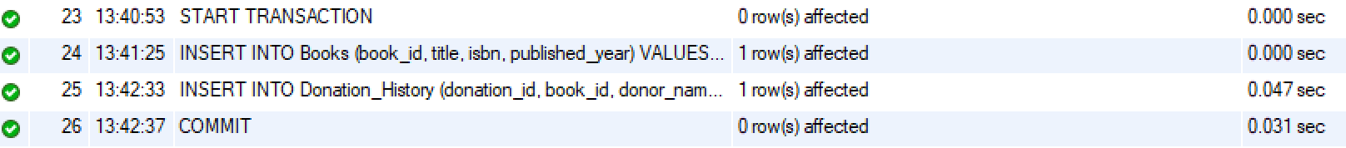
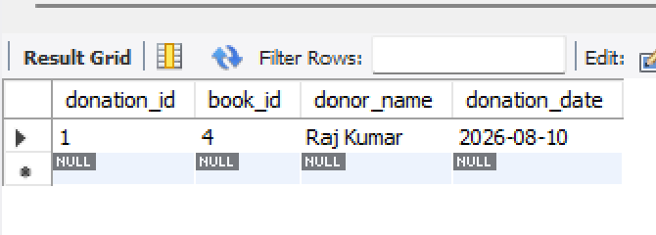
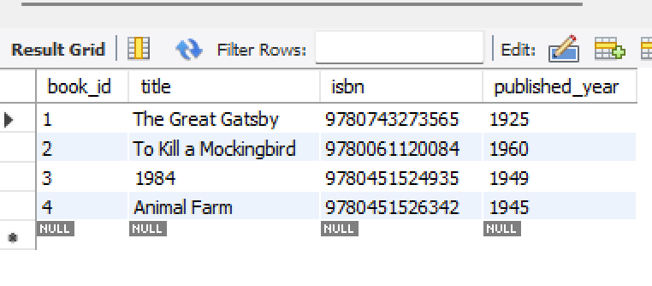
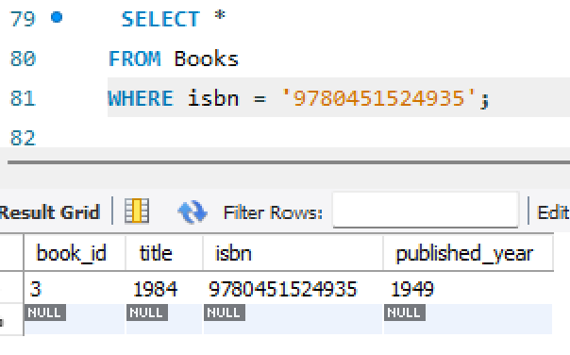
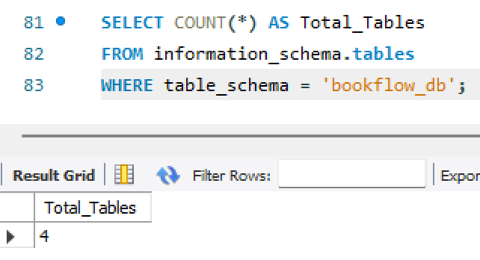
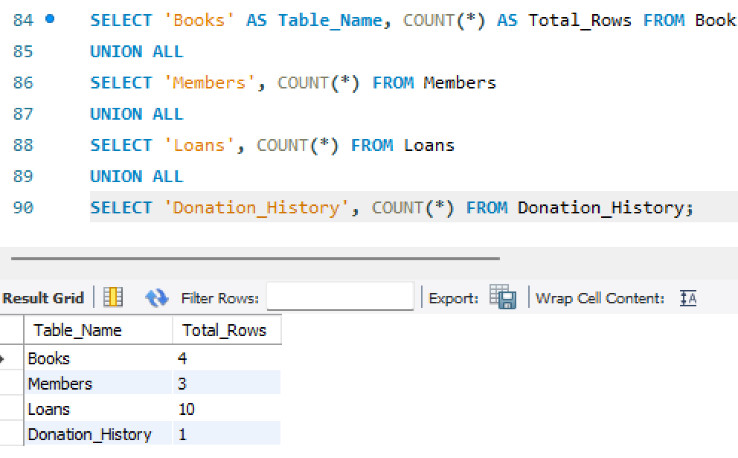

ASSIGNMENTS :
Problem statement 1: : Sky Track Airline Management System
A regional airline company currently manages its flight schedules, passenger records, and ticket bookings using spreadsheets. As the number of flights and passengers continues to grow, it has become difficult to track reservations, maintain accurate records, and generate operational reports. To improve efficiency, the airline plans to develop a database system called SkyTrack. As a database developer, your task is to create a database named skytrack_db and design three tables: Flights, Passengers, and Bookings. The Flights table should contain details such as flight_id, flight_number, source, destination, departure_date, and ticket_price, while the Passengers table should store passenger_id, passenger_name, and email. The Bookings table should connect passengers and flights using passenger_id and flight_id as foreign keys. Apply appropriate constraints, including PRIMARY KEY, UNIQUE, and CHECK constraints to ensure data integrity. Insert at least 10 records into each table. Display all table contents and write an SQL query using INNER JOIN to show the passenger name, flight number, source, and destination for every booking. Generate a report showing the total number of flights operating to each destination using COUNT() and GROUP BY. Create a Flight_History table and demonstrate the use of a Transaction by adding a new flight and simultaneously recording the entry in the history table, ensuring both operations succeed or fail together. Finally, create an Index on the flight_number column and explain why searching by flight number is faster than searching by destination. This exercise develops skills in relational database design, JOIN operations, aggregate functions, transactions, and indexing.

CREATE DATABASE IF NOT EXISTS skytrack_db;
USE skytrack_db;
SELECT DATABASE();
CREATE TABLE Flights (
flight_id INT PRIMARY KEY,
flight_number VARCHAR(20) NOT NULL UNIQUE,
source VARCHAR(50) NOT NULL,
destination VARCHAR(50) NOT NULL,
departure_date DATE NOT NULL,
ticket_price DECIMAL(10,2) CHECK (ticket_price > 0)
);
DESCRIBE Flights;
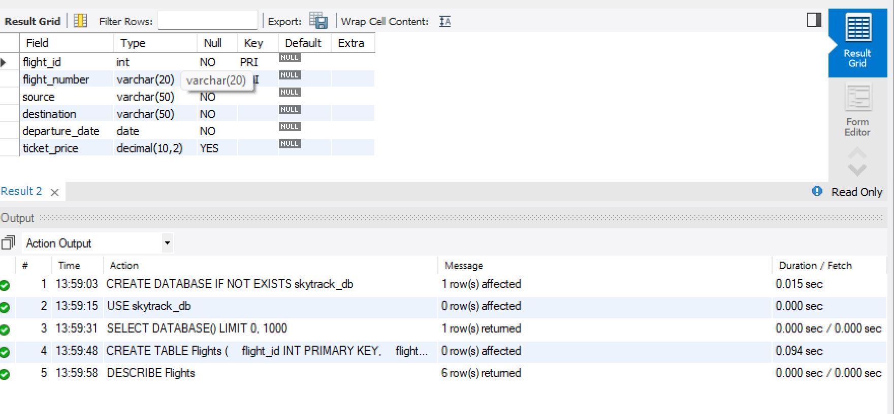
CREATE TABLE Passengers (
passenger_id INT PRIMARY KEY,
passenger_name VARCHAR(100) NOT NULL,
email VARCHAR(100) NOT NULL UNIQUE
);
DESCRIBE Passengers;
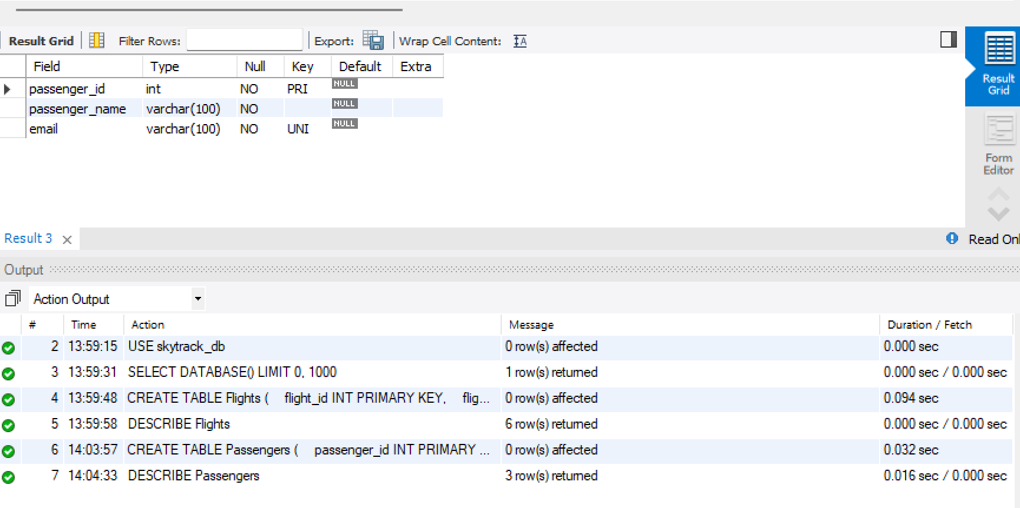
CREATE TABLE Bookings (
booking_id INT PRIMARY KEY,
passenger_id INT NOT NULL,
flight_id INT NOT NULL,
booking_date DATE NOT NULL,

FOREIGN KEY (passenger_id)
REFERENCES Passengers(passenger_id),

FOREIGN KEY (flight_id)
REFERENCES Flights(flight_id)
);
DESCRIBE Bookings;
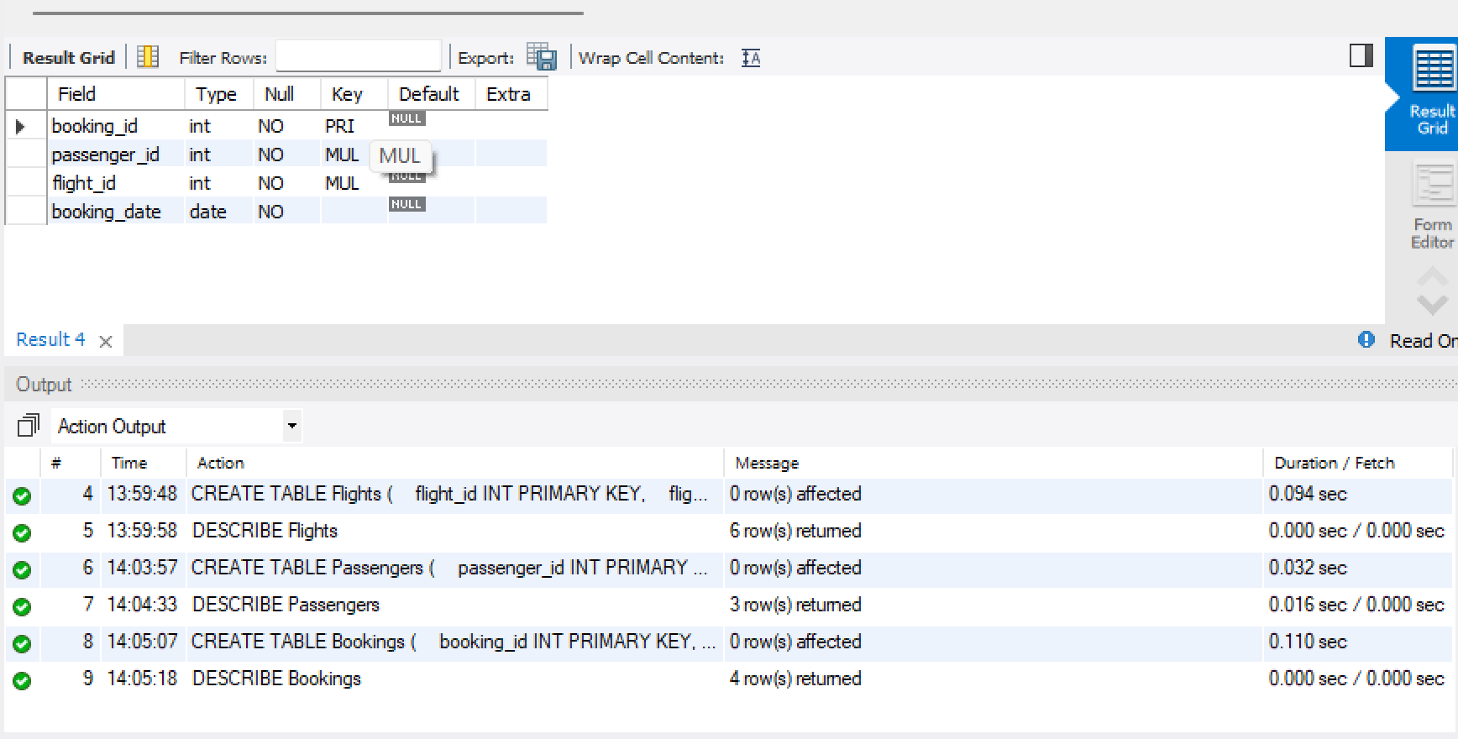
INSERT INTO Flights
(flight_id, flight_number, source, destination, departure_date, ticket_price)
VALUES
(1, 'ST101', 'Hyderabad', 'Delhi', '2026-09-01', 5500.00),
(2, 'ST102', 'Hyderabad', 'Mumbai', '2026-09-02', 4800.00),
(3, 'ST103', 'Chennai', 'Delhi', '2026-09-03', 6200.00),
(4, 'ST104', 'Bangalore', 'Hyderabad', '2026-09-04', 3500.00),
(5, 'ST105', 'Mumbai', 'Kolkata', '2026-09-05', 7000.00),
(6, 'ST106', 'Delhi', 'Chennai', '2026-09-06', 6500.00),
(7, 'ST107', 'Hyderabad', 'Bangalore', '2026-09-07', 4000.00),
(8, 'ST108', 'Kolkata', 'Mumbai', '2026-09-08', 5800.00),
(9, 'ST109', 'Chennai', 'Hyderabad', '2026-09-09', 4200.00),
(10, 'ST110', 'Delhi', 'Bangalore', '2026-09-10', 6100.00);
SELECT * FROM Flights;
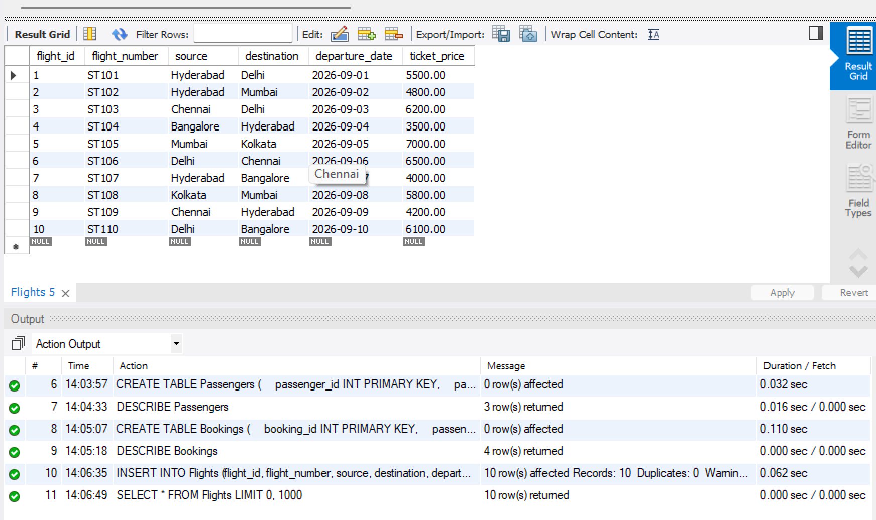
INSERT INTO Passengers
(passenger_id, passenger_name, email)
VALUES
(101, 'Rahul Sharma', 'rahul@gmail.com'),
(102, 'Priya Reddy', 'priya@gmail.com'),
(103, 'Amit Kumar', 'amit@gmail.com'),
(104, 'Sneha Rao', 'sneha@gmail.com'),
(105, 'Kiran Patel', 'kiran@gmail.com'),
(106, 'Anjali Singh', 'anjali@gmail.com'),
(107, 'Vijay Kumar', 'vijay@gmail.com'),
(108, 'Meena Das', 'meena@gmail.com'),
(109, 'Arjun Reddy', 'arjun@gmail.com'),
(110, 'Kavya Sharma', 'kavya@gmail.com');
SELECT * FROM Passengers;
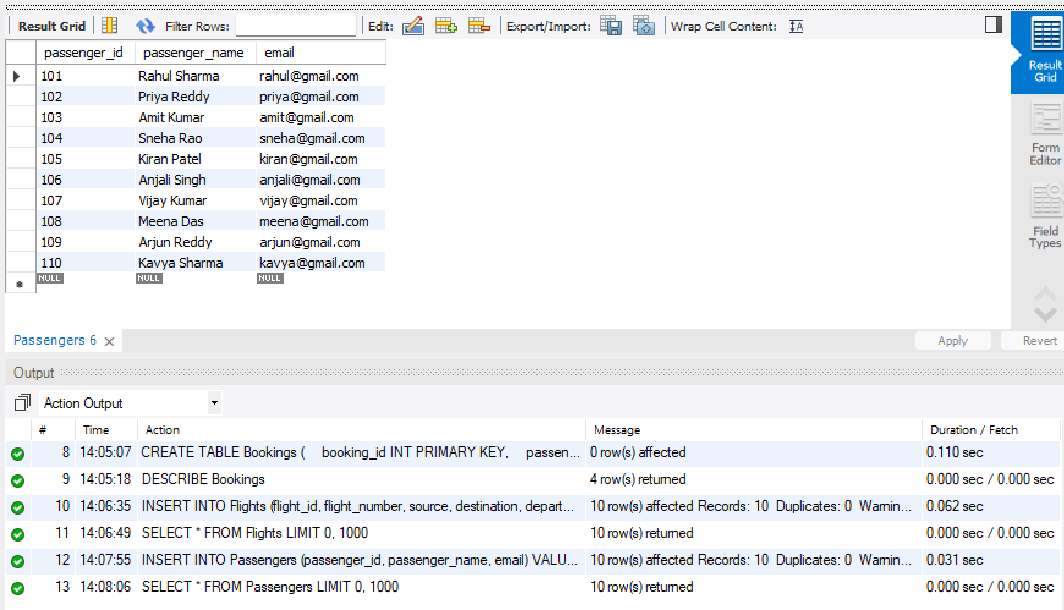
INSERT INTO Bookings
(booking_id, passenger_id, flight_id, booking_date)
VALUES
(1, 101, 1, '2026-08-01'),
(2, 102, 2, '2026-08-02'),
(3, 103, 3, '2026-08-03'),
(4, 104, 4, '2026-08-04'),
(5, 105, 5, '2026-08-05'),
(6, 106, 6, '2026-08-06'),
(7, 107, 7, '2026-08-07'),
(8, 108, 8, '2026-08-08'),
(9, 109, 9, '2026-08-09'),
(10, 110, 10, '2026-08-10');
SELECT * FROM Bookings;
SELECT * FROM Flights;

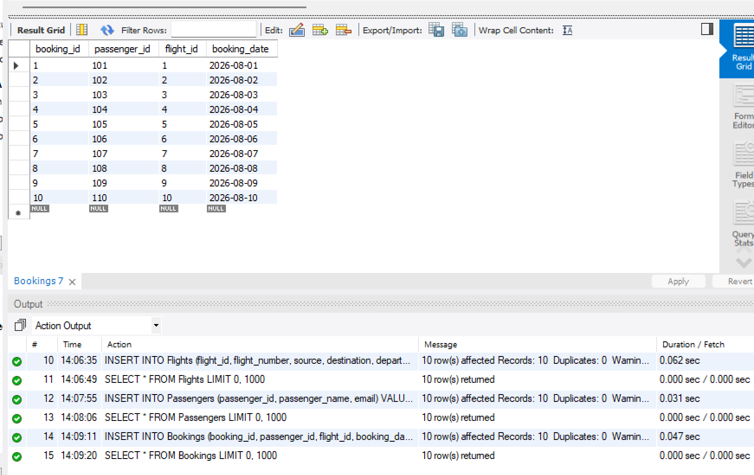
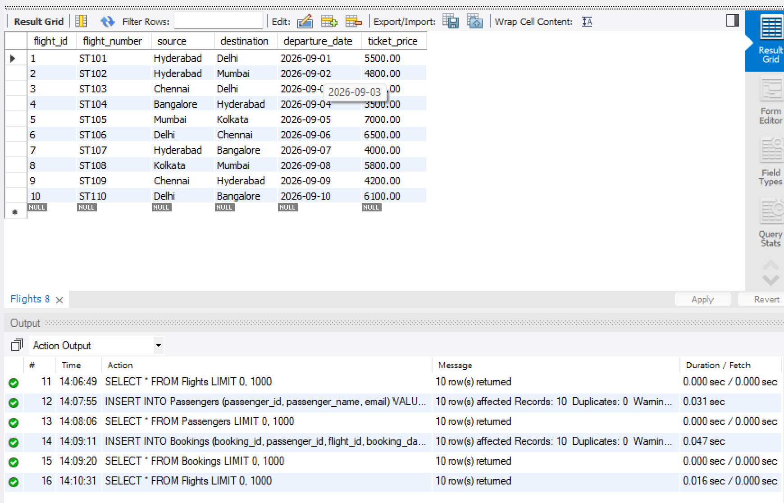
SELECT * FROM Passengers;
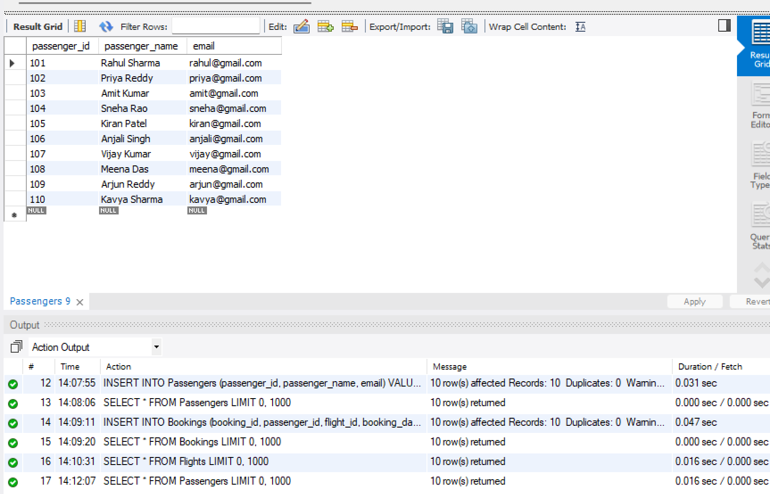
SELECT * FROM Bookings;
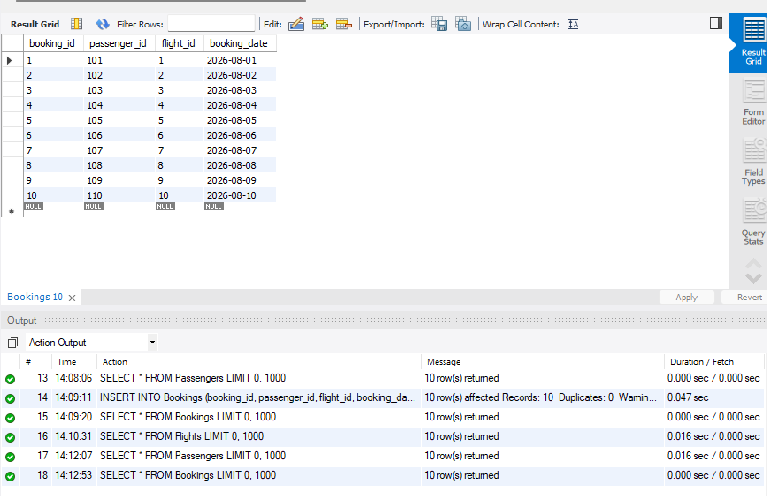
SELECT
p.passenger_name AS Passenger_Name,
f.flight_number AS Flight_Number,
f.source AS Source,
f.destination AS Destination
FROM Bookings b
INNER JOIN Passengers p
ON b.passenger_id = p.passenger_id
INNER JOIN Flights f
ON b.flight_id = f.flight_id;
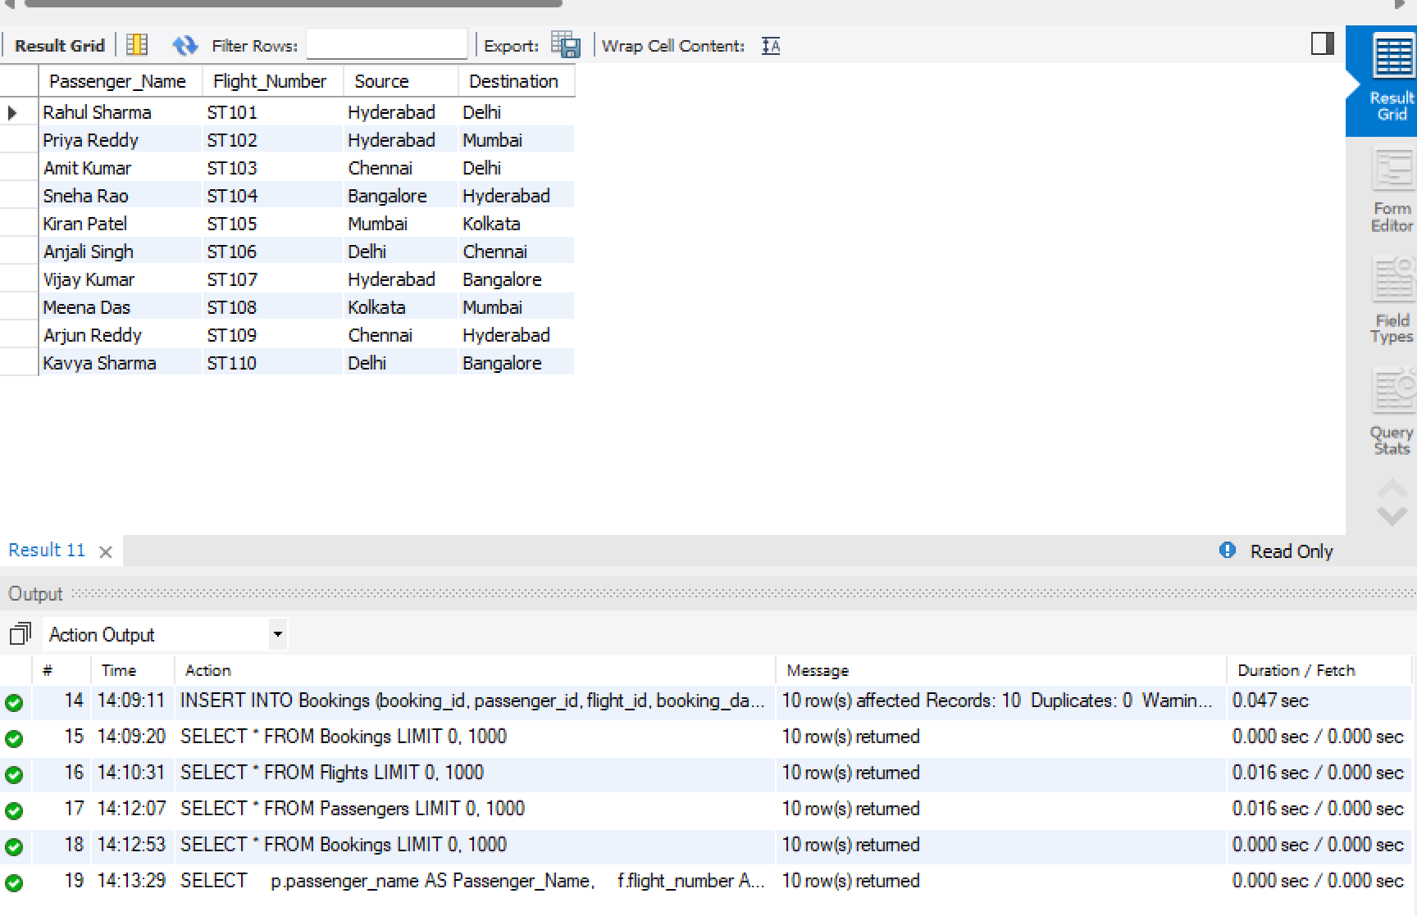
SELECT
destination,
COUNT(*) AS Total_Flights
FROM Flights
GROUP BY destination;
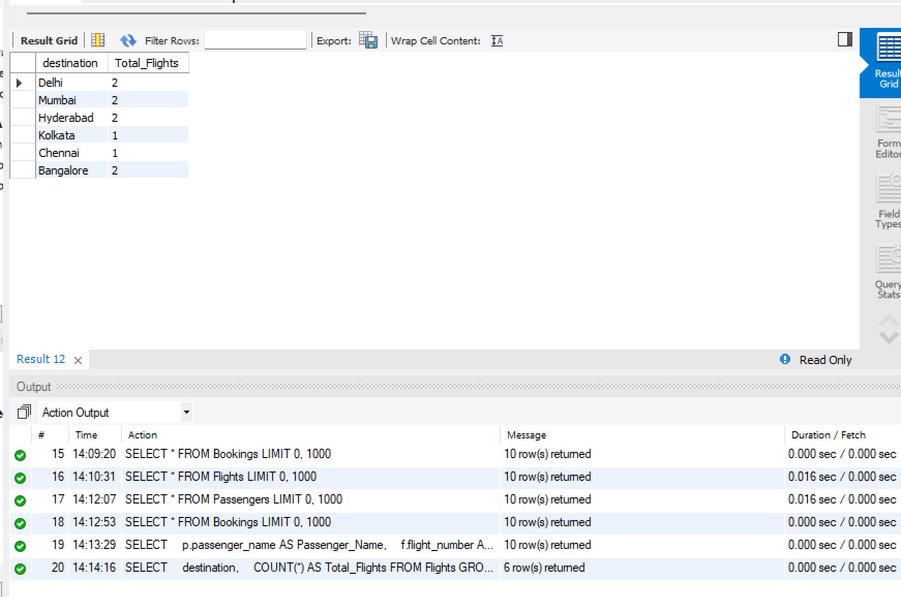
SELECT
destination,
COUNT(*) AS Total_Flights
FROM Flights
GROUP BY destination
ORDER BY Total_Flights DESC;
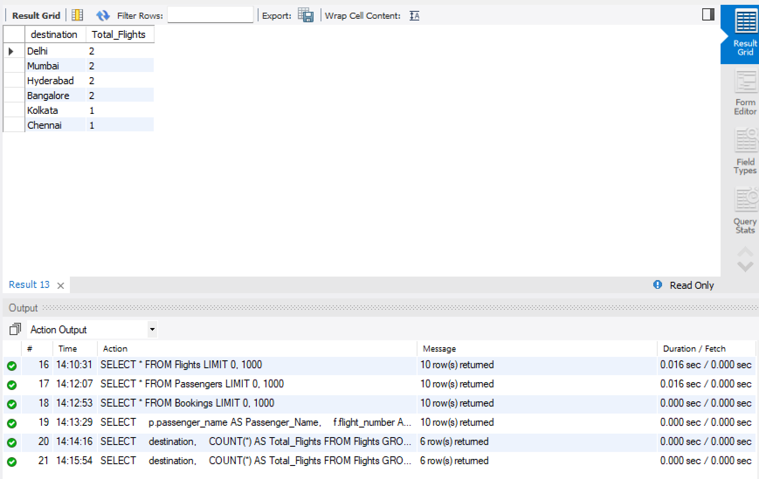
CREATE TABLE Flight_History (
history_id INT PRIMARY KEY,
flight_id INT NOT NULL,
action VARCHAR(50) NOT NULL,
action_date DATE NOT NULL,

FOREIGN KEY (flight_id)
REFERENCES Flights(flight_id)
);
DESCRIBE Flight_History;
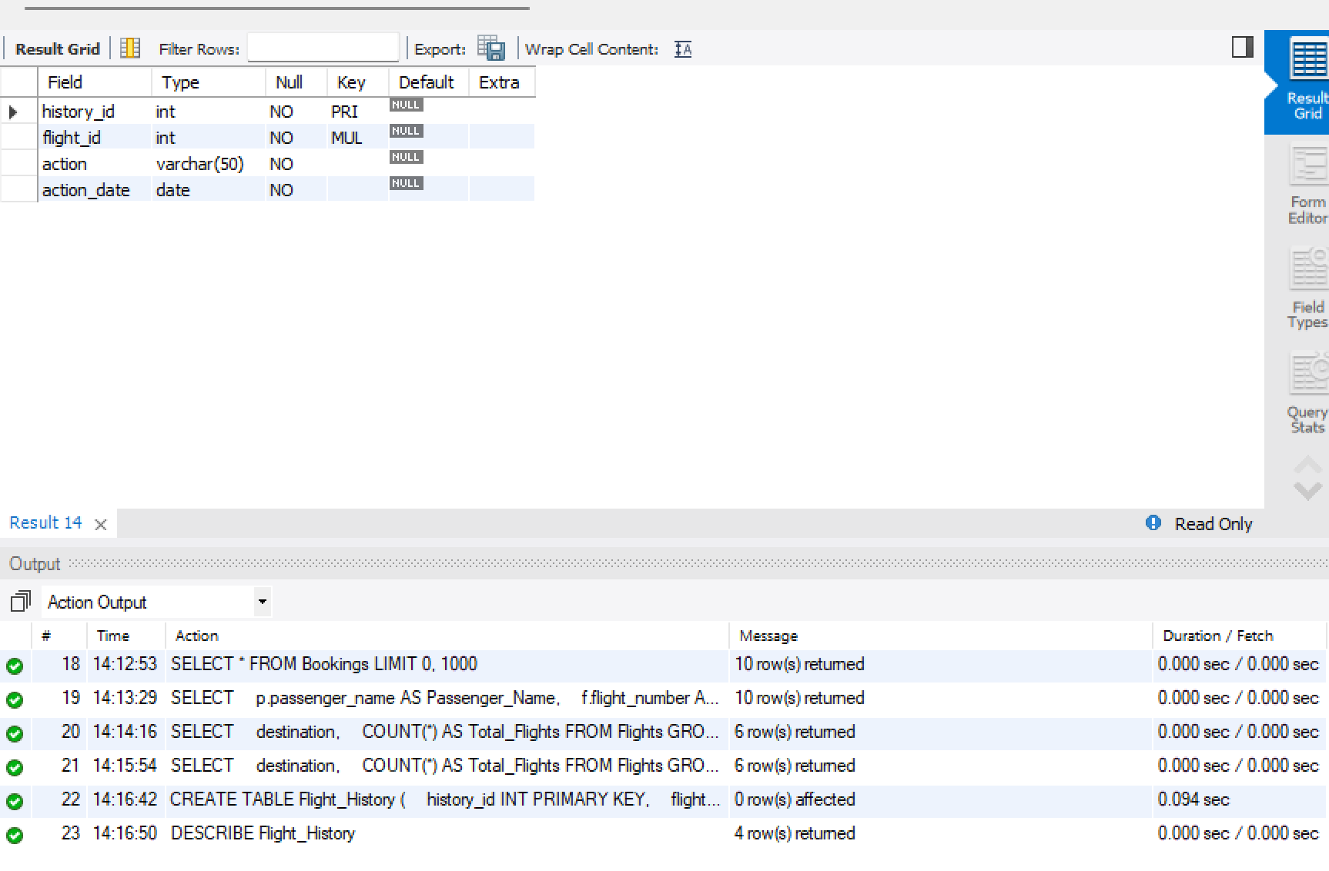
START TRANSACTION;
INSERT INTO Flights
(flight_id, flight_number, source, destination, departure_date, ticket_price)
VALUES
(11, 'ST111', 'Hyderabad', 'Pune', '2026-09-11', 4500.00);
INSERT INTO Flight_History
(history_id, flight_id, action, action_date)
VALUES
(1, 11, 'NEW FLIGHT ADDED', CURDATE());
COMMIT;
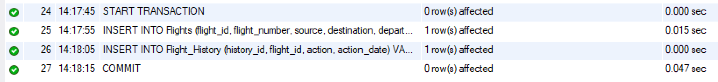
SELECT * FROM Flights
WHERE flight_id = 11;
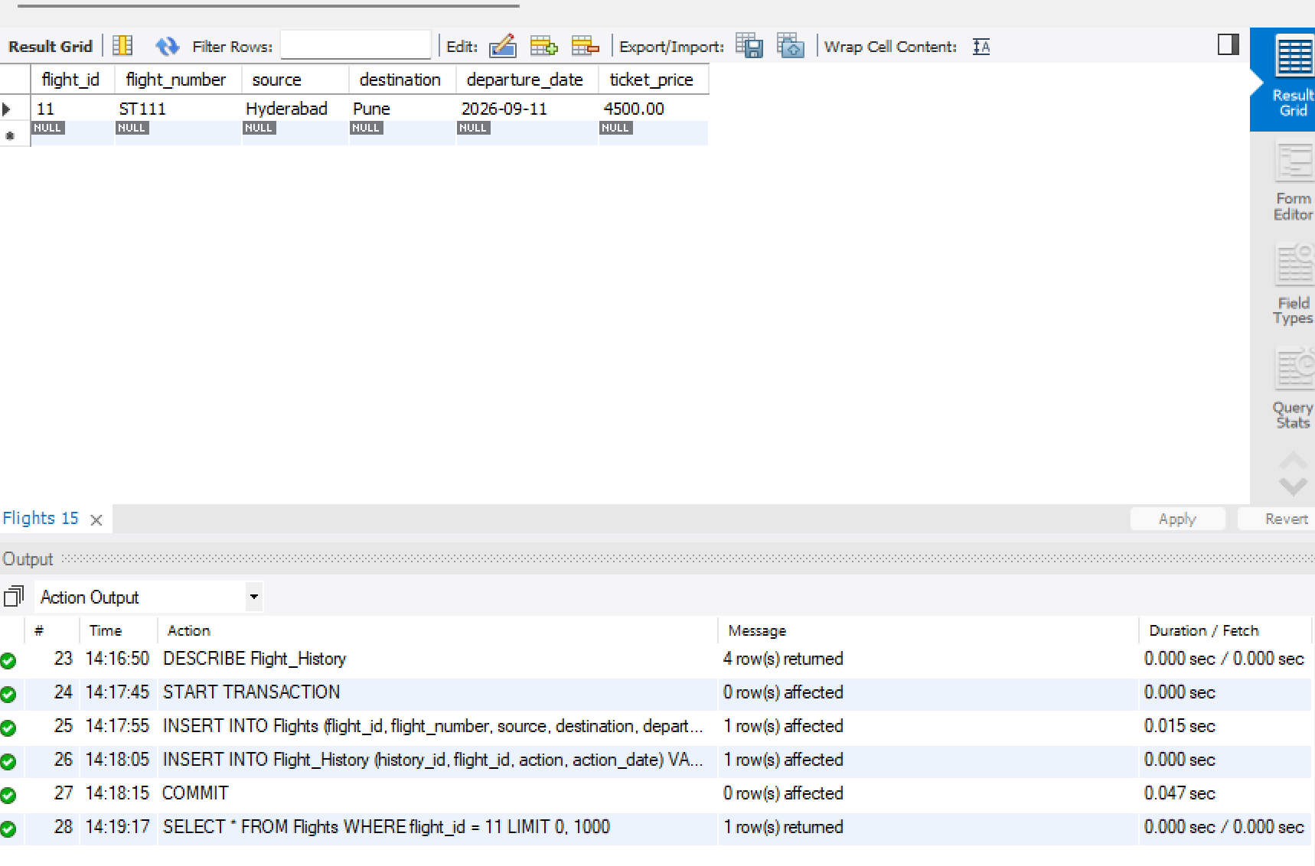
SELECT * FROM Flight_History;
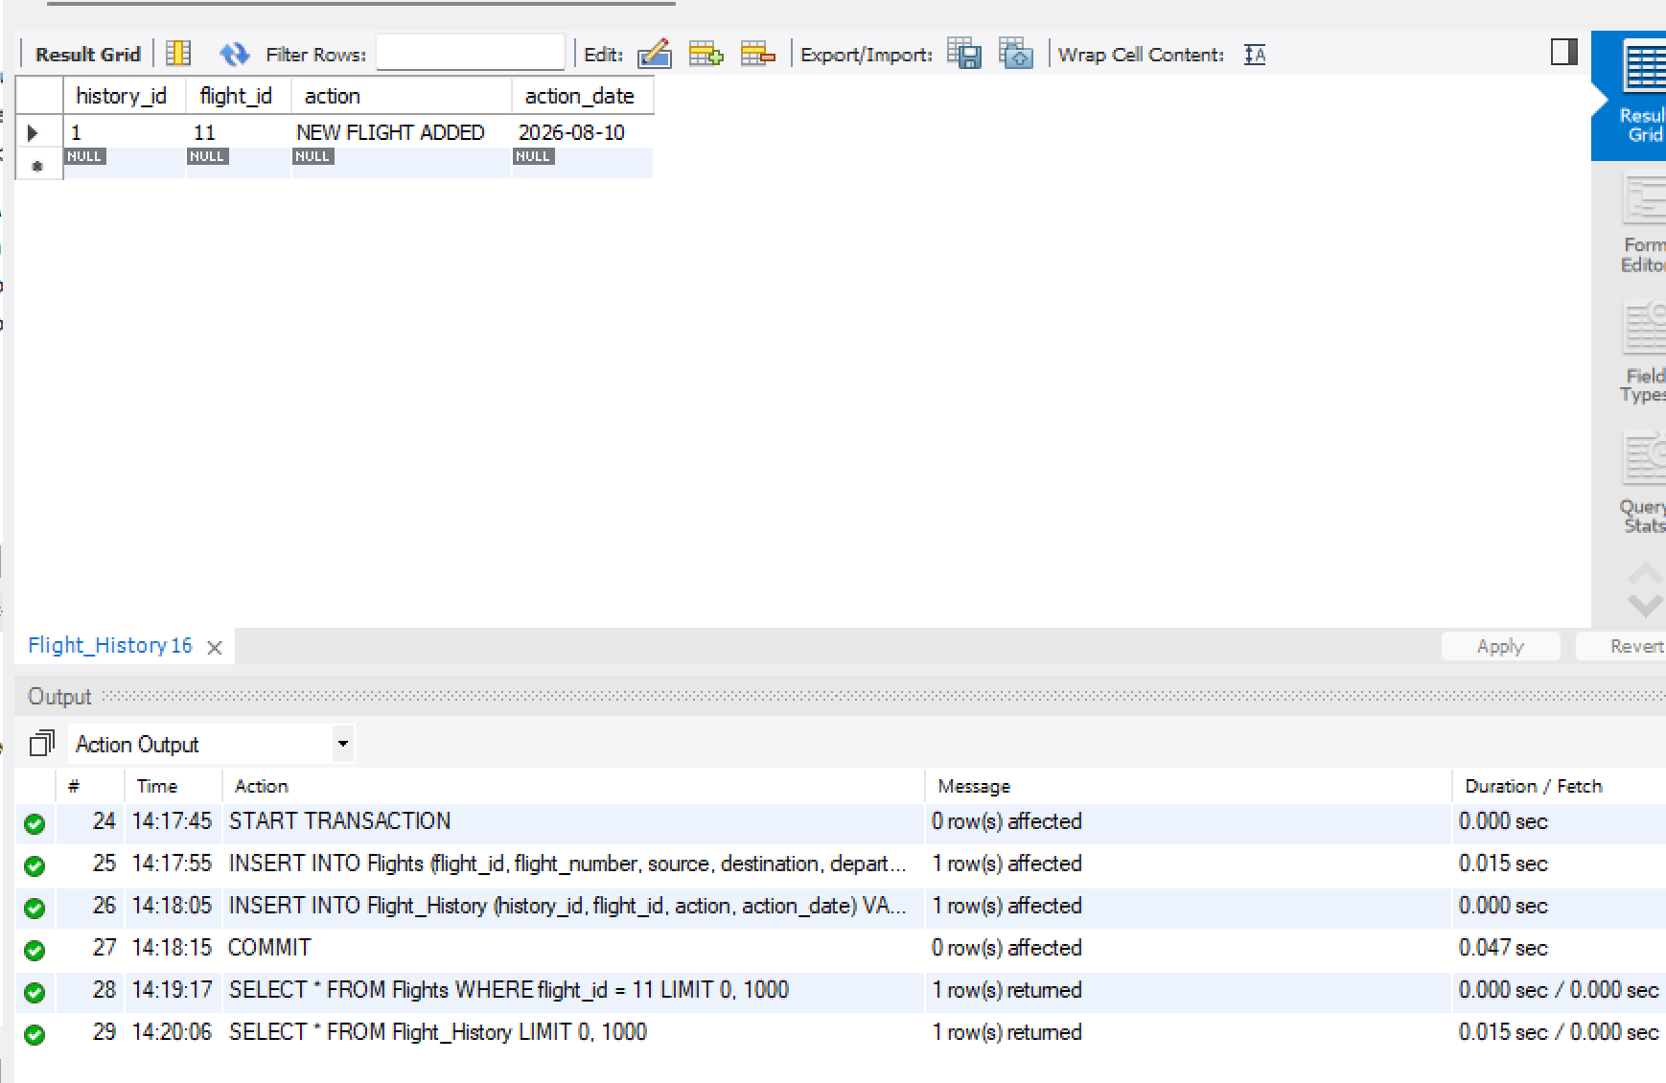
START TRANSACTION;
INSERT INTO Flights
(flight_id, flight_number, source, destination, departure_date, ticket_price)
VALUES
(12, 'ST112', 'Delhi', 'Pune', '2026-09-12', 5200.00);
SELECT * FROM Flights
WHERE flight_id = 12;
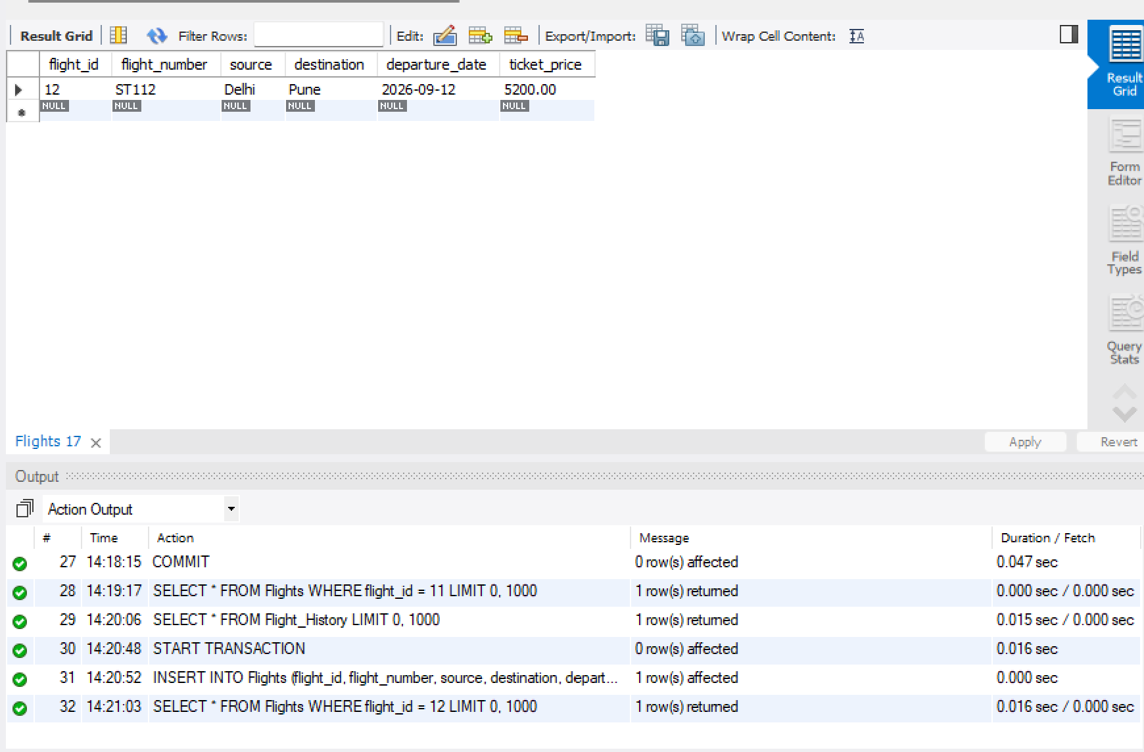
ROLLBACK;
SELECT * FROM Flights
WHERE flight_id = 12;
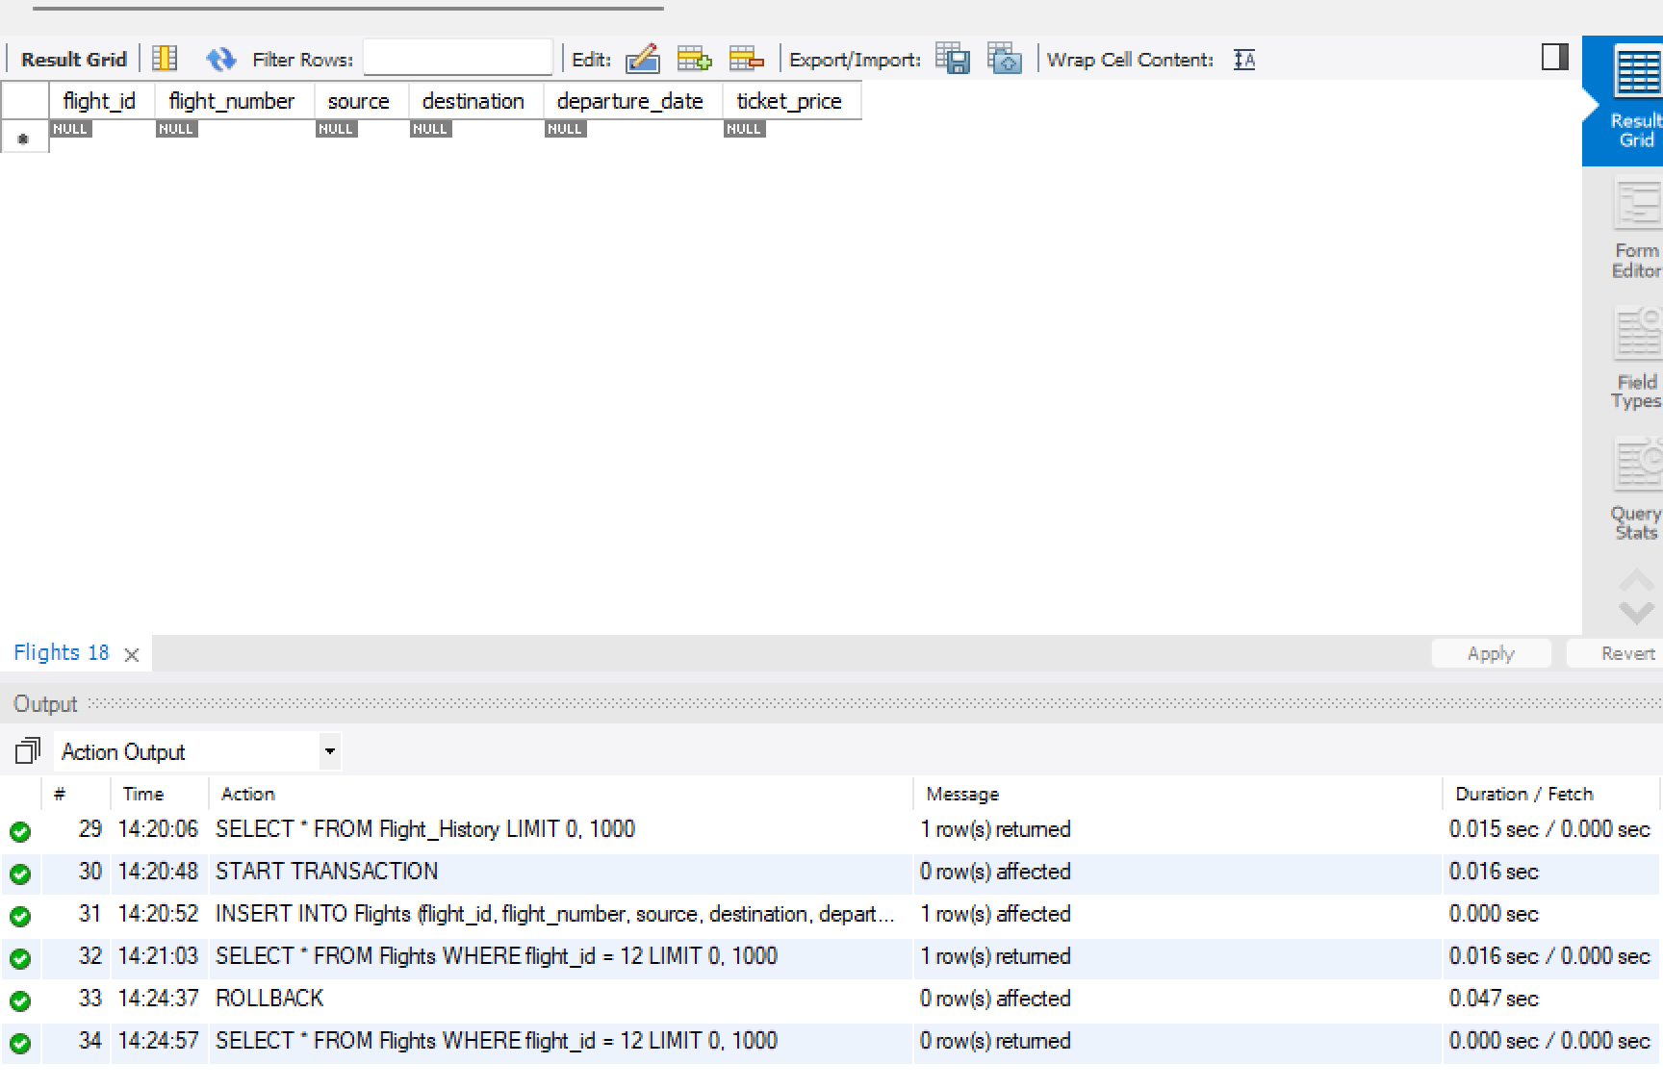

CREATE INDEX idx_flights_flight_number
ON Flights(flight_number);
SHOW INDEX FROM Flights;
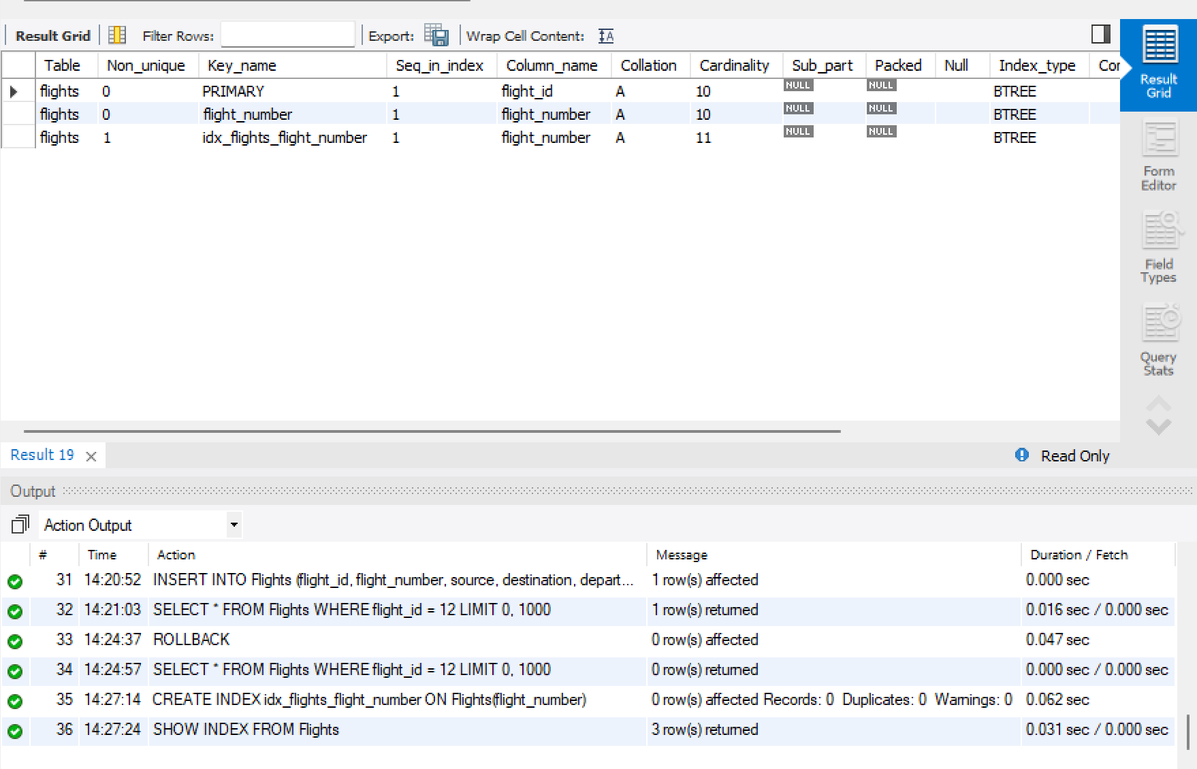
SELECT *
FROM Flights
WHERE flight_number = 'ST105';
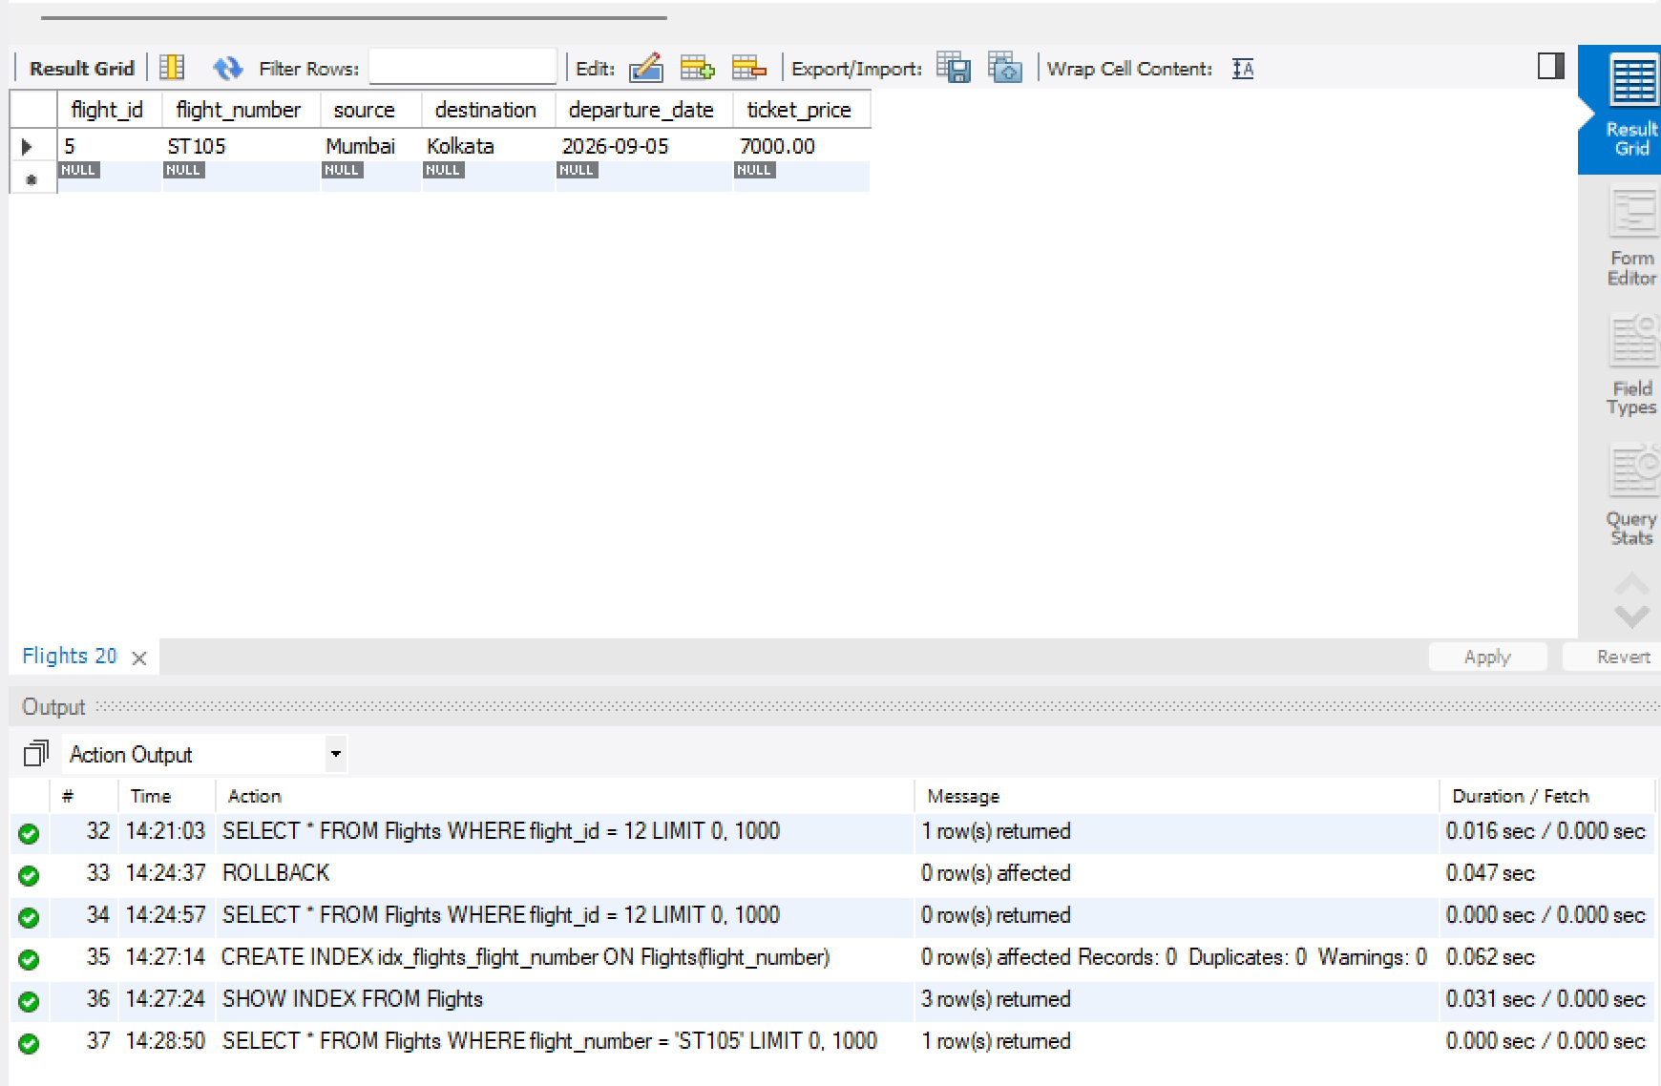
SELECT *
FROM Flights
WHERE flight_number = 'ST105';

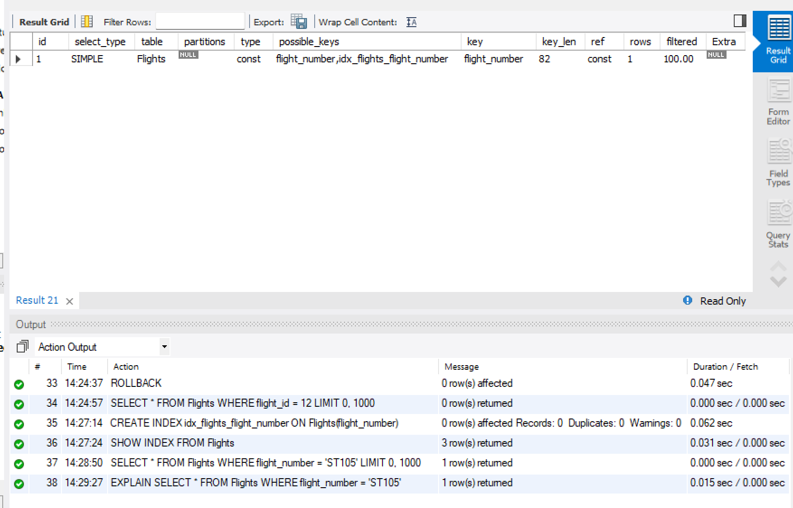
SELECT *
FROM Flights
WHERE destination = 'Delhi';
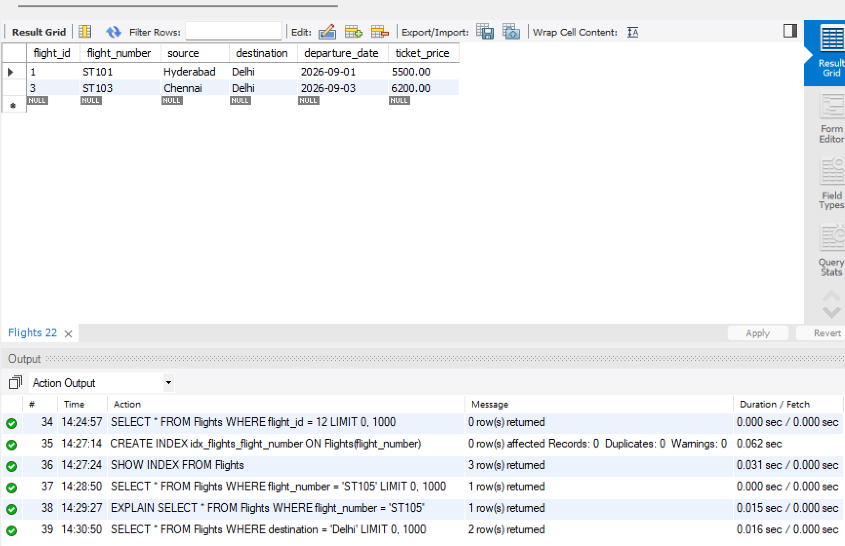
SHOW TABLES;
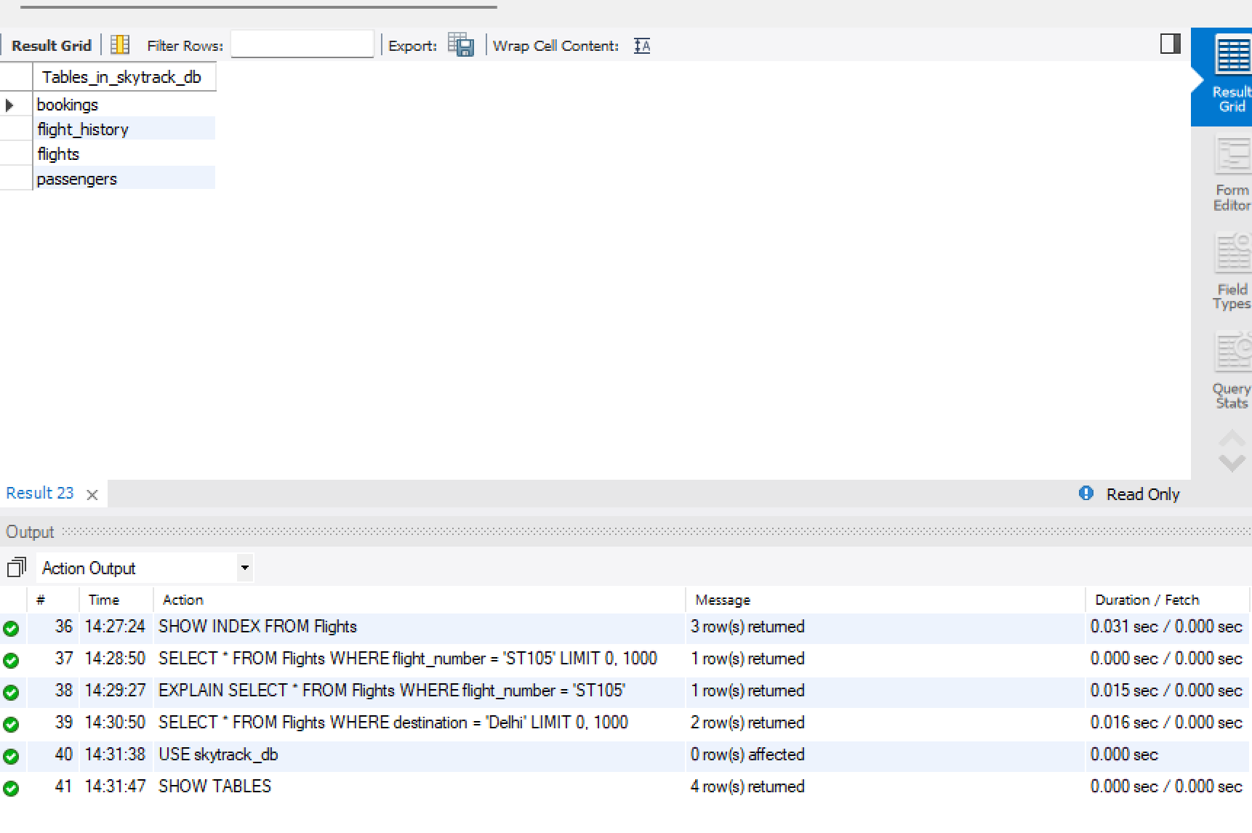
SELECT 'Flights' AS Table_Name, COUNT(*) AS Total_Rows
FROM Flights
UNION ALL
SELECT 'Passengers', COUNT(*)
FROM Passengers
UNION ALL
SELECT 'Bookings', COUNT(*)
FROM Bookings
UNION ALL
SELECT 'Flight_History', COUNT(*)
FROM Flight_History;
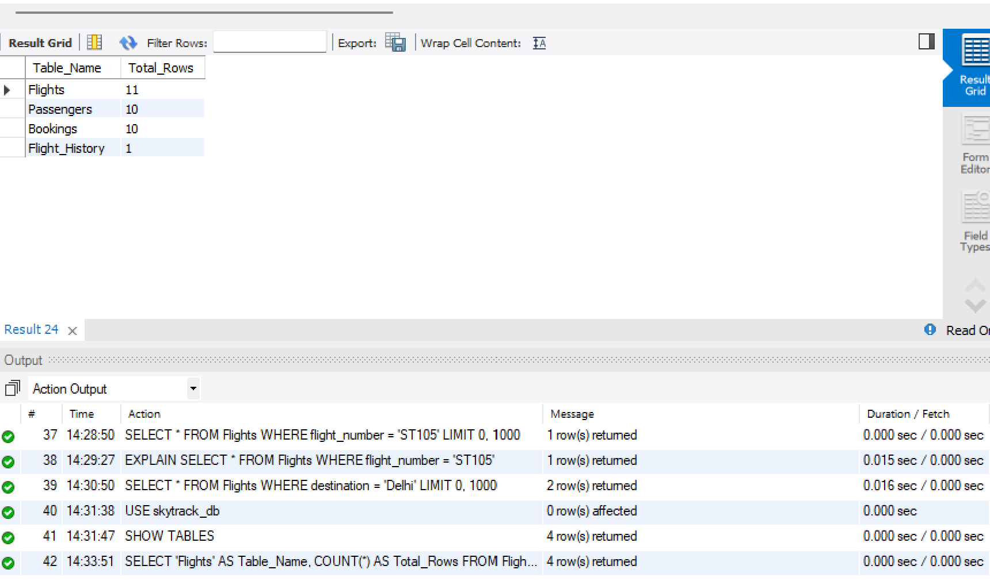
SELECT * FROM Flights;
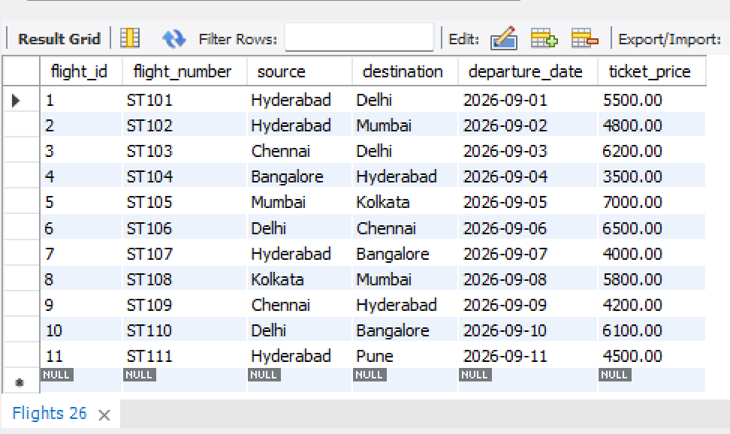
SELECT * FROM Passengers;
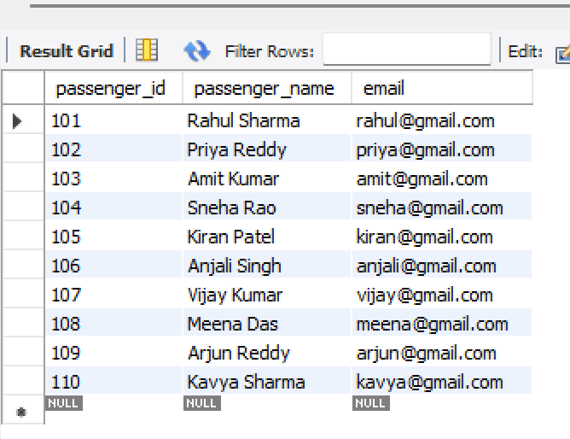
SELECT * FROM Bookings;
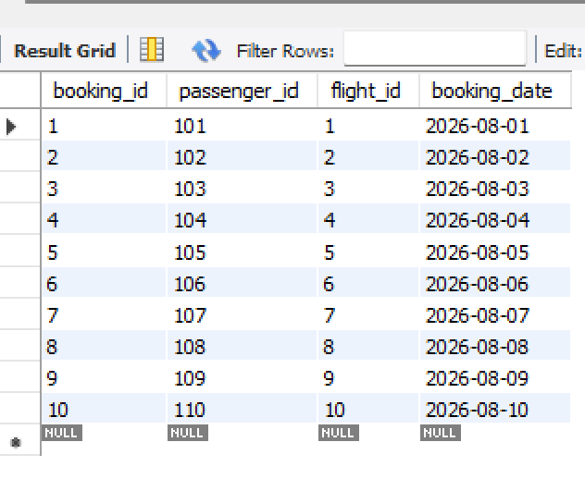
SELECT * FROM Flight_History;
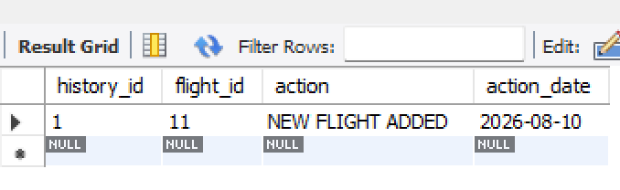
SELECT
p.passenger_name AS Passenger_Name,
f.flight_number AS Flight_Number,
f.source AS Source,
f.destination AS Destination
FROM Bookings b
INNER JOIN Passengers p
ON b.passenger_id = p.passenger_id
INNER JOIN Flights f
ON b.flight_id = f.flight_id;
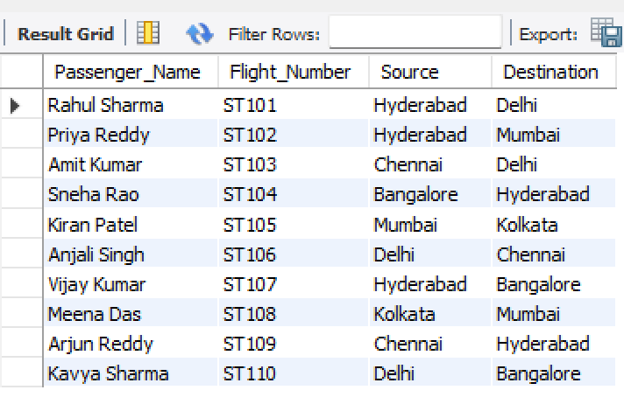
SELECT
destination,
COUNT(*) AS Total_Flights
FROM Flights
GROUP BY destination
ORDER BY Total_Flights DESC;
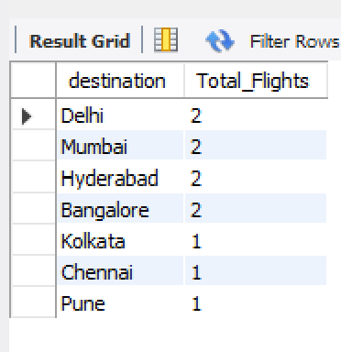

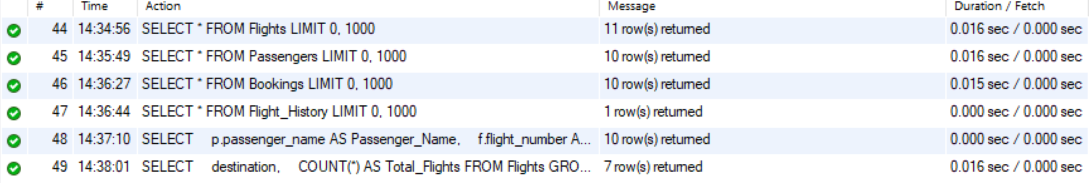

Problem Statement 2: Medicare Hospital Management System
A hospital currently maintains patient records, doctor information, and appointment schedules manually, which often results in scheduling conflicts, misplaced records, and delays in accessing important information. To modernize its operations, the hospital wants to develop a database system called MediCare HMS. As a database developer, your task is to create a database named medicare_db and design three tables: Doctors, Patients, and Appointments. The Doctors table should store details such as doctor_id, doctor_name, specialization, and consultation_fee, while the Patients table should contain patient_id, patient_name, and email. The Appointments table should connect doctors and patients using foreign keys and include an appointment date. Apply appropriate constraints such as PRIMARY KEY, UNIQUE, and CHECK constraints to ensure data accuracy and consistency. Insert at least 10 records into each table. Display all table contents and write an SQL query using INNER JOIN to show the patient name, doctor name, specialization, and appointment date for all appointments. Generate a report displaying the number of doctors available in each specialization using COUNT() and GROUP BY. Create a Doctor_History table and demonstrate the use of a Transaction by registering a new doctor and simultaneously recording the registration in the history table, ensuring both operations are completed successfully as a single unit. Finally, create an Index on the specialization column and explain how indexing improves search performance when locating doctors by specialization. This exercise helps students understand database design, table relationships, SQL queries, aggregate functions, transactions, and query optimization techniques.

CREATE DATABASE IF NOT EXISTS medicare_db;
USE medicare_db;
SELECT DATABASE();
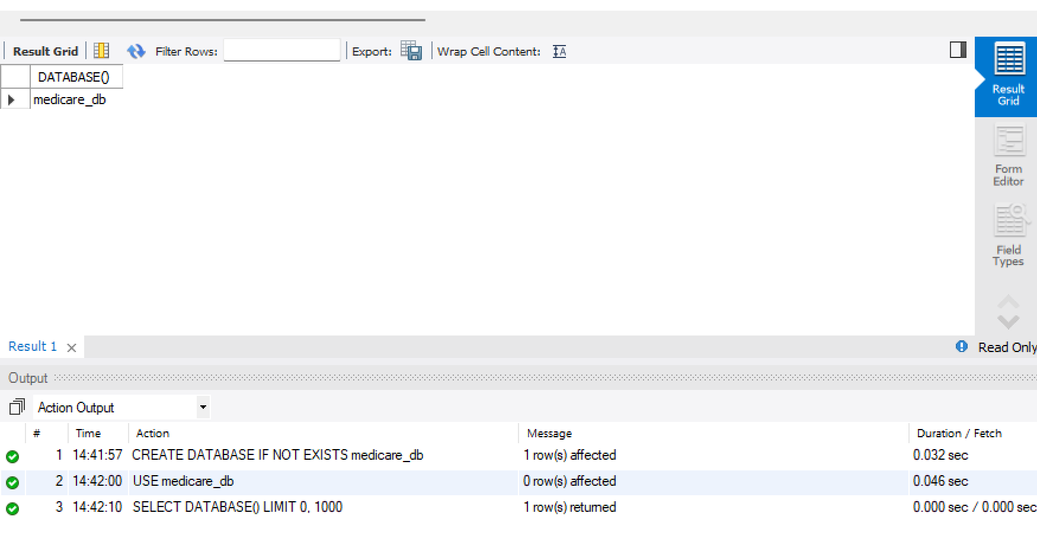

CREATE TABLE Doctors (
doctor_id INT PRIMARY KEY,
doctor_name VARCHAR(100) NOT NULL,
specialization VARCHAR(100) NOT NULL,
consultation_fee DECIMAL(10,2) CHECK (consultation_fee > 0)
);
DESCRIBE Doctors;
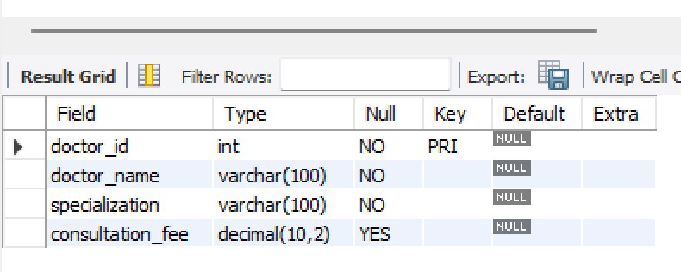
CREATE TABLE Patients (
patient_id INT PRIMARY KEY,
patient_name VARCHAR(100) NOT NULL,
email VARCHAR(100) NOT NULL UNIQUE
);
DESCRIBE Patients;
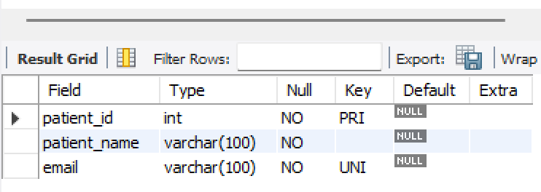
CREATE TABLE Appointments (
appointment_id INT PRIMARY KEY,
doctor_id INT NOT NULL,
patient_id INT NOT NULL,
appointment_date DATE NOT NULL,

FOREIGN KEY (doctor_id)
REFERENCES Doctors(doctor_id),

FOREIGN KEY (patient_id)
REFERENCES Patients(patient_id)
);
DESCRIBE Appointments;
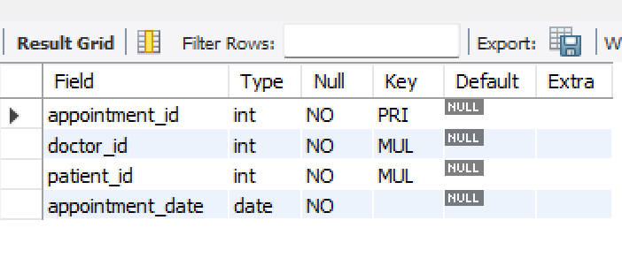
INSERT INTO Doctors
(doctor_id, doctor_name, specialization, consultation_fee)
VALUES
(1, 'Dr. Ravi Kumar', 'Cardiology', 800.00),
(2, 'Dr. Priya Sharma', 'Neurology', 1000.00),
(3, 'Dr. Anil Reddy', 'Orthopedics', 700.00),
(4, 'Dr. Sneha Rao', 'Dermatology', 600.00),
(5, 'Dr. Kiran Patel', 'Cardiology', 900.00),
(6, 'Dr. Meena Singh', 'Pediatrics', 500.00),
(7, 'Dr. Arjun Das', 'Neurology', 1100.00),
(8, 'Dr. Kavya Reddy', 'Gynecology', 750.00),
(9, 'Dr. Vijay Kumar', 'Orthopedics', 850.00),
(10, 'Dr. Anjali Rao', 'Dermatology', 650.00);
SELECT * FROM Doctors;
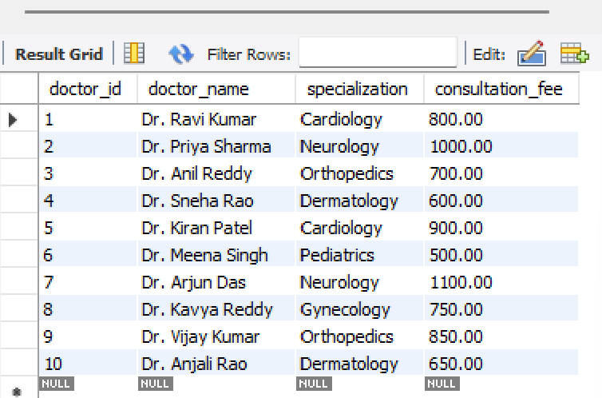
INSERT INTO Patients
(patient_id, patient_name, email)
VALUES
(101, 'Rahul Sharma', 'rahul.patient@gmail.com'),
(102, 'Sita Reddy', 'sita.patient@gmail.com'),
(103, 'Amit Kumar', 'amit.patient@gmail.com'),
(104, 'Sneha Patel', 'sneha.patient@gmail.com'),
(105, 'Kiran Rao', 'kiran.patient@gmail.com'),
(106, 'Anjali Singh', 'anjali.patient@gmail.com'),
(107, 'Vijay Das', 'vijay.patient@gmail.com'),
(108, 'Meena Reddy', 'meena.patient@gmail.com'),
(109, 'Arjun Sharma', 'arjun.patient@gmail.com'),
(110, 'Kavya Kumar', 'kavya.patient@gmail.com');
SELECT * FROM Patients;
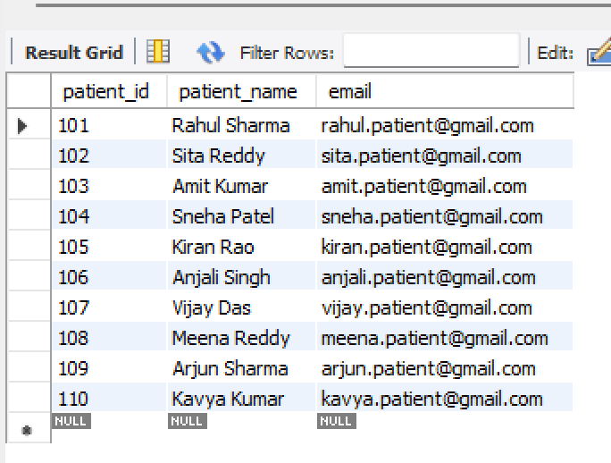
INSERT INTO Appointments
(appointment_id, doctor_id, patient_id, appointment_date)
VALUES
(1, 1, 101, '2026-08-11'),
(2, 2, 102, '2026-08-12'),
(3, 3, 103, '2026-08-13'),
(4, 4, 104, '2026-08-14'),
(5, 5, 105, '2026-08-15'),
(6, 6, 106, '2026-08-16'),
(7, 7, 107, '2026-08-17'),
(8, 8, 108, '2026-08-18'),
(9, 9, 109, '2026-08-19'),
(10, 10, 110, '2026-08-20');
SELECT * FROM Appointments;
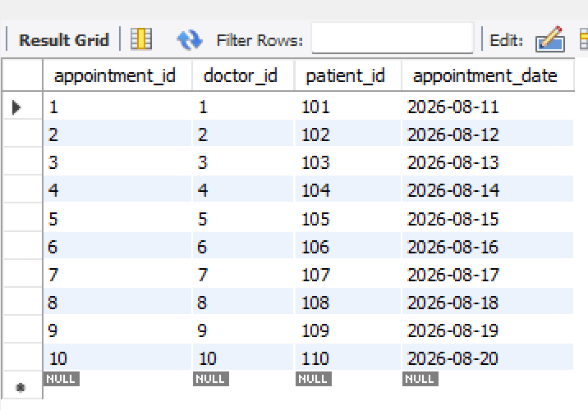
SELECT
p.patient_name AS Patient_Name,
d.doctor_name AS Doctor_Name,
d.specialization AS Specialization,
a.appointment_date AS Appointment_Date
FROM Appointments a
INNER JOIN Patients p
ON a.patient_id = p.patient_id
INNER JOIN Doctors d
ON a.doctor_id = d.doctor_id;

SELECT
specialization,
COUNT(*) AS Total_Doctors
FROM Doctors
GROUP BY specialization;
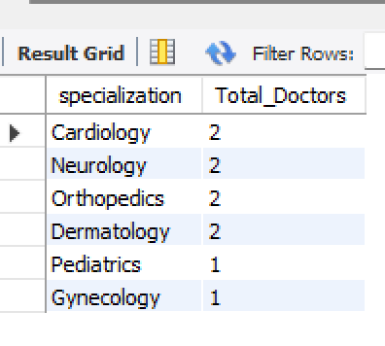
CREATE TABLE Doctor_History (
history_id INT PRIMARY KEY,
doctor_id INT NOT NULL,
action VARCHAR(50) NOT NULL,
action_date DATE NOT NULL,

FOREIGN KEY (doctor_id)
REFERENCES Doctors(doctor_id)
);
DESCRIBE Doctor_History;
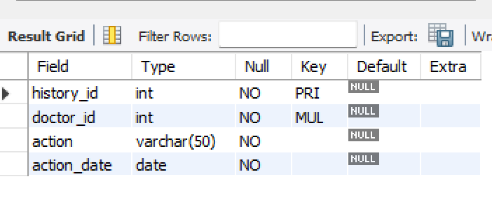
START TRANSACTION;
INSERT INTO Doctors
(doctor_id, doctor_name, specialization, consultation_fee)
VALUES
(11, 'Dr. Neha Verma', 'Cardiology', 950.00);
INSERT INTO Doctor_History
(history_id, doctor_id, action, action_date)
VALUES
(1, 11, 'NEW DOCTOR REGISTERED', CURDATE());
COMMIT;
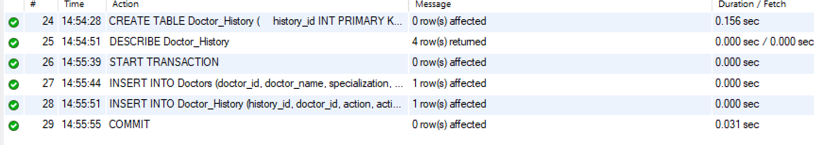
SELECT *
FROM Doctors
WHERE doctor_id = 11;
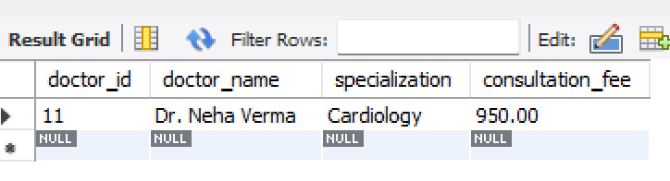
SELECT * FROM Doctor_History;
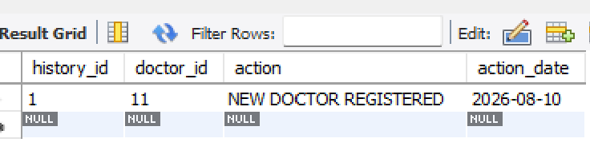
START TRANSACTION;
INSERT INTO Doctors
(doctor_id, doctor_name, specialization, consultation_fee)
VALUES
(12, 'Dr. Raj Malhotra', 'Neurology', 1200.00);
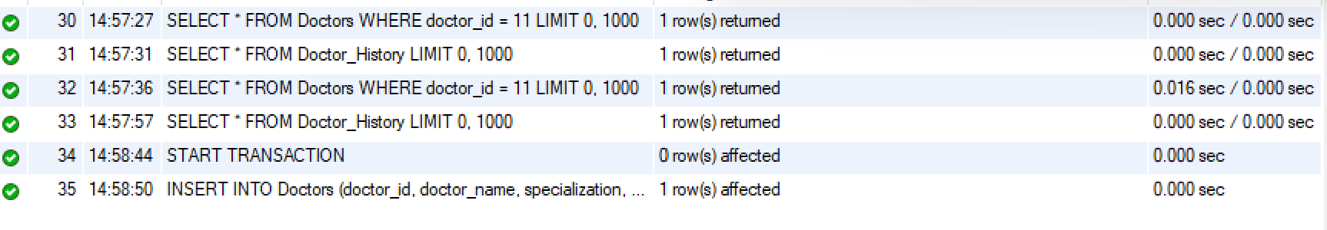
SELECT *
FROM Doctors
WHERE doctor_id = 12;
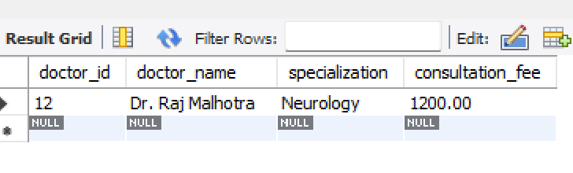
ROLLBACK;
SELECT *
FROM Doctors
WHERE doctor_id = 12;
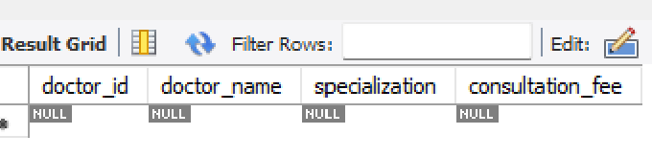
CREATE INDEX idx_doctors_specialization
ON Doctors(specialization);
SHOW INDEX FROM Doctors;
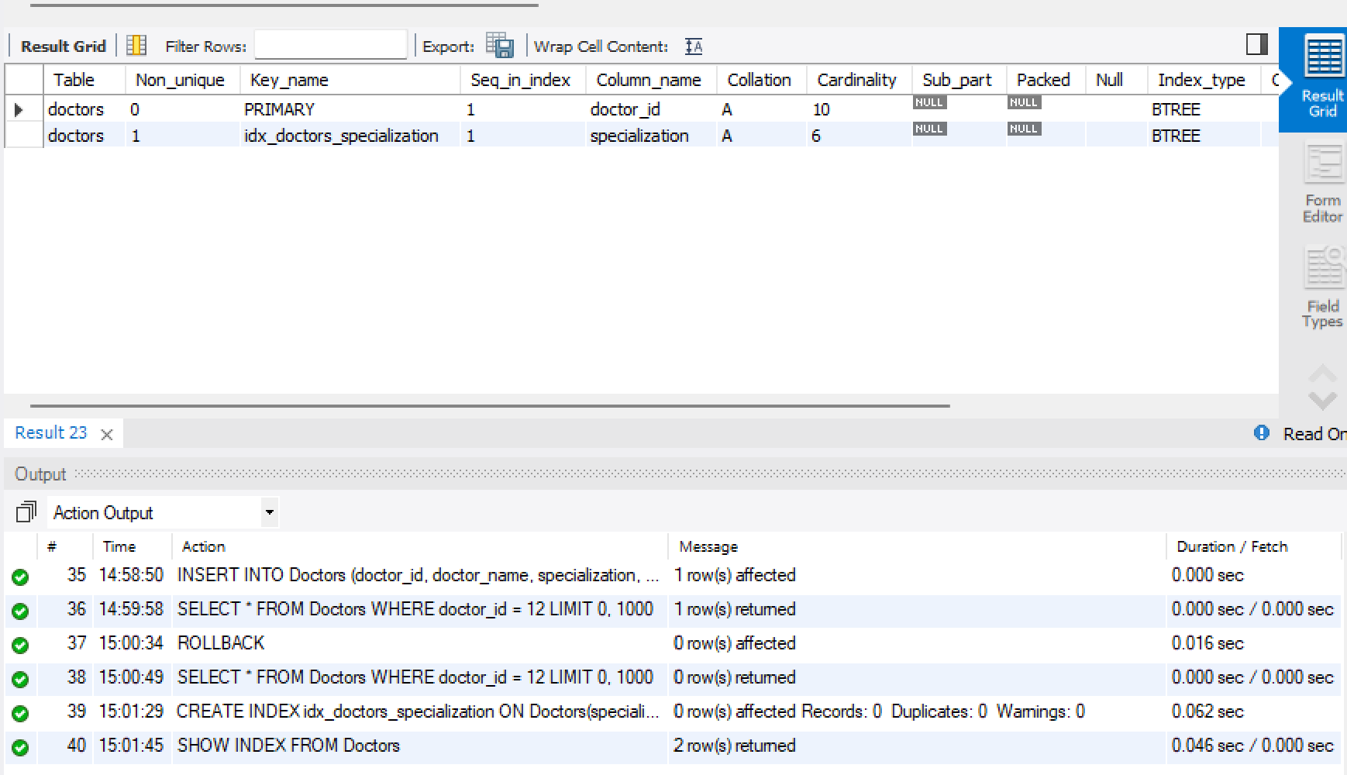
SELECT *
FROM Doctors
WHERE specialization = 'Cardiology';
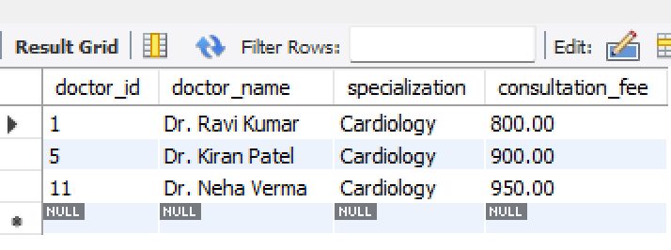
EXPLAIN
SELECT *
FROM Doctors
WHERE specialization = 'Cardiology';
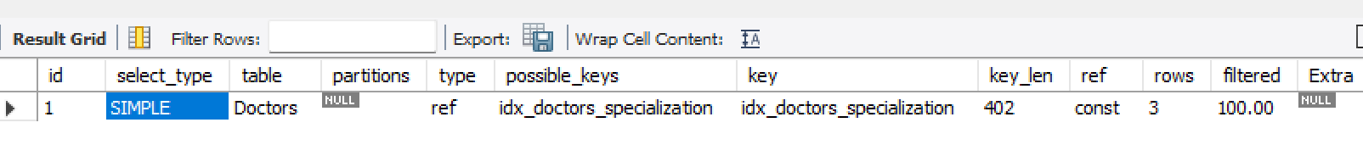
SHOW TABLES;
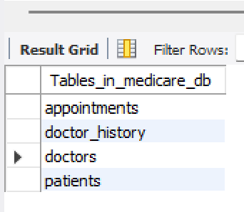
SELECT COUNT(*) AS Total_Tables
FROM information_schema.tables
WHERE table_schema = 'medicare_db';
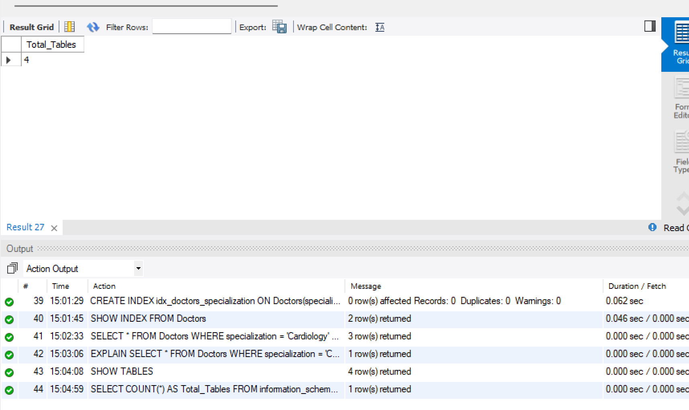
SELECT 'Doctors' AS Table_Name, COUNT(*) AS Total_Rows
FROM Doctors
UNION ALL
SELECT 'Patients', COUNT(*)
FROM Patients
UNION ALL
SELECT 'Appointments', COUNT(*)
FROM Appointments
UNION ALL
SELECT 'Doctor_History', COUNT(*)
FROM Doctor_History;
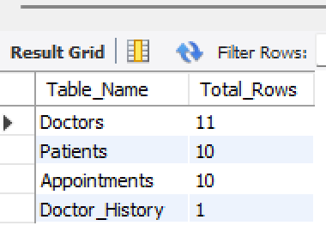
SELECT
p.patient_name AS Patient_Name,
d.doctor_name AS Doctor_Name,
d.specialization AS Specialization,
a.appointment_date AS Appointment_Date
FROM Appointments a
INNER JOIN Patients p
ON a.patient_id = p.patient_id
INNER JOIN Doctors d
ON a.doctor_id = d.doctor_id;
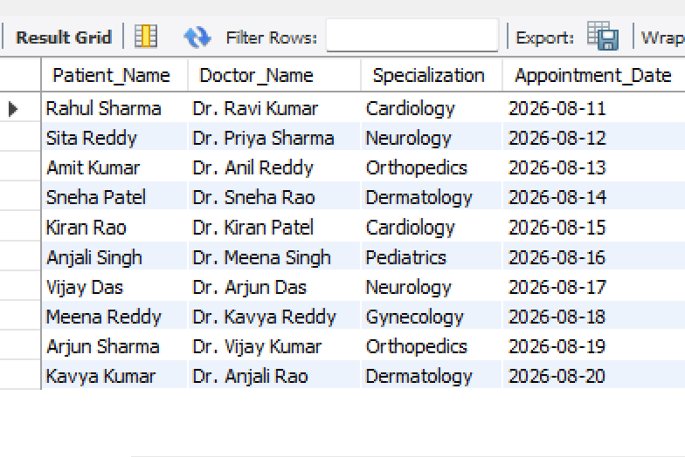
SELECT
specialization,
COUNT(*) AS Total_Doctors
FROM Doctors
GROUP BY specialization
ORDER BY Total_Doctors DESC;

